TELECOM SUPPORT
Salesforce Support Ticket Management System
Project Documentation & System Architecture
Prepared from implementation screenshots | 20 October 2026

1. Executive Summary
Telecom Support is a Salesforce Lightning application for managing telecom customer support tickets, calculating service-level agreement (SLA) deadlines, escalating qualifying tickets, sending email notifications, and presenting ticket metrics through reports and dashboards.

2. Objectives
- Centralize customer issues in a custom Support Ticket object.
- Calculate SLA deadlines according to ticket priority.
- Escalate eligible Low-priority tickets to High after four hours if they remain open and Low.
- Send high-priority notifications, SLA deadline reminders, and SLA-breach alerts.
- Monitor ticket records through reports and a dashboard.

3. System Architecture
Salesforce Lightning App: Telecom Support
Support Ticket Object
├─ Data layer: Ticket Number, Subject, Customer Name, Category, Description, Priority, SLA Deadline, Status, Customer Sentiment
├─ Automation layer (Flow Builder)
│ ├─ Set Support Ticket SLA
│ ├─ Escalate Critical Support Tickets
│ ├─ High Priority Ticket Notification
│ ├─ SLA Deadline Reminder
│ └─ SLA Breach Detection
├─ Notification layer: Salesforce Email Alerts
└─ Analytics layer: Support Ticket Overview Report → Telecom Support Dashboard
Data flow: ticket creation or update → SLA calculation and scheduled evaluation → priority escalation or email alert when conditions are met → report and dashboard summarize ticket data.

4. Data Model
Primary object: Support Ticket (API name shown in Flow Builder as Support_Ticket__c).
Field | Purpose
Ticket Number | Auto-number identifier, shown as ST-{00000}.
Subject / Description | Issue title and details.
Customer Name | Customer label entered on the ticket.
Category | Issue classification; sample records show Network Issue.
Priority | Low, Medium, or High; drives SLA and escalation logic.
SLA Deadline | Target date/time for handling the ticket.
Status | Ticket lifecycle state; sample records show New.
Customer Sentiment | Positive, Neutral, or Negative.

5. Automation Design

5.1 Set Support Ticket SLA
Record-triggered flow on Support Ticket, triggered when a record is created and optimized for Fast Field Updates. A priority decision routes the record through High, Medium, or Low branches before setting SLA Deadline. Configured offsets: High = current time + 4 hours; Medium = current time + 8 hours; Low = current time + 1 day.

5.2 Escalate Critical Support Tickets
The scheduled path “Escalate After 4 Hours” checks whether a ticket remains Low priority and open. The qualifying branch runs “Escalate Ticket to High.” Tickets no longer meeting the conditions should follow the default outcome.

5.3 High Priority Ticket Notification
An update-triggered flow invokes “Send High Priority Alert.” The alert runs only when the flow entry criteria are met. A captured debug run was marked Not Triggered because the test record did not meet its start conditions.

5.4 SLA Deadline Reminder
The scheduled path “SLA Reminder” evaluates the ticket and invokes “Send SLA Deadline Reminder” when its configured outcome is met.

5.5 SLA Breach Detection
The scheduled path “SLA Breach Check” evaluates ticket status and compares SLA Deadline with a date/time resource labelled Current_Date_Time. The qualifying outcome invokes “Send SLA Breach Alert.” Validate this path using a ticket whose deadline has passed.

6. Reporting and Dashboard
The custom report type “Support Tickets” powers the “Support Ticket Overview” report. It displays Ticket Number, Subject, Status, Category, SLA Deadline, and Customer Sentiment, grouped by Priority. The captured report contains five records: Low = 3, Medium = 1, High = 1.
The “Telecom Support Dashboard” displays a donut chart with Record Count sliced by Priority. The captured dashboard shows five total tickets. Counts reflect the screenshot time and will change as records change.

7. Test Evidence
Area | Evidence from screenshots
SLA calculation | Priority decision and High/Medium/Low branches are visible.
Escalation | Four-hour scheduled path and assignment to High are visible.
High-priority alert | Email alert action is visible; one debug run did not meet entry conditions.
SLA reminder | Scheduled reminder path and email action are visible.
SLA breach | Scheduled breach decision and email action are visible.
Analytics | Report and dashboard show five sample tickets grouped by priority.

8. Limitations and Production Readiness
- Flow diagrams and active status demonstrate configuration, but do not prove every scheduled path completed or every email was delivered.
- Test every flow with records that meet entry criteria, including tickets closed before a scheduled path executes.
- Verify email deliverability, sender configuration, recipients, and time-zone behavior in the target org.
- Consider fault paths, error logging, and history tracking for escalation and alert outcomes.
- The report and dashboard currently reflect a small demonstration dataset.

9. Screenshot Evidence
Figure 1. Support Ticket Overview report grouped by priority.
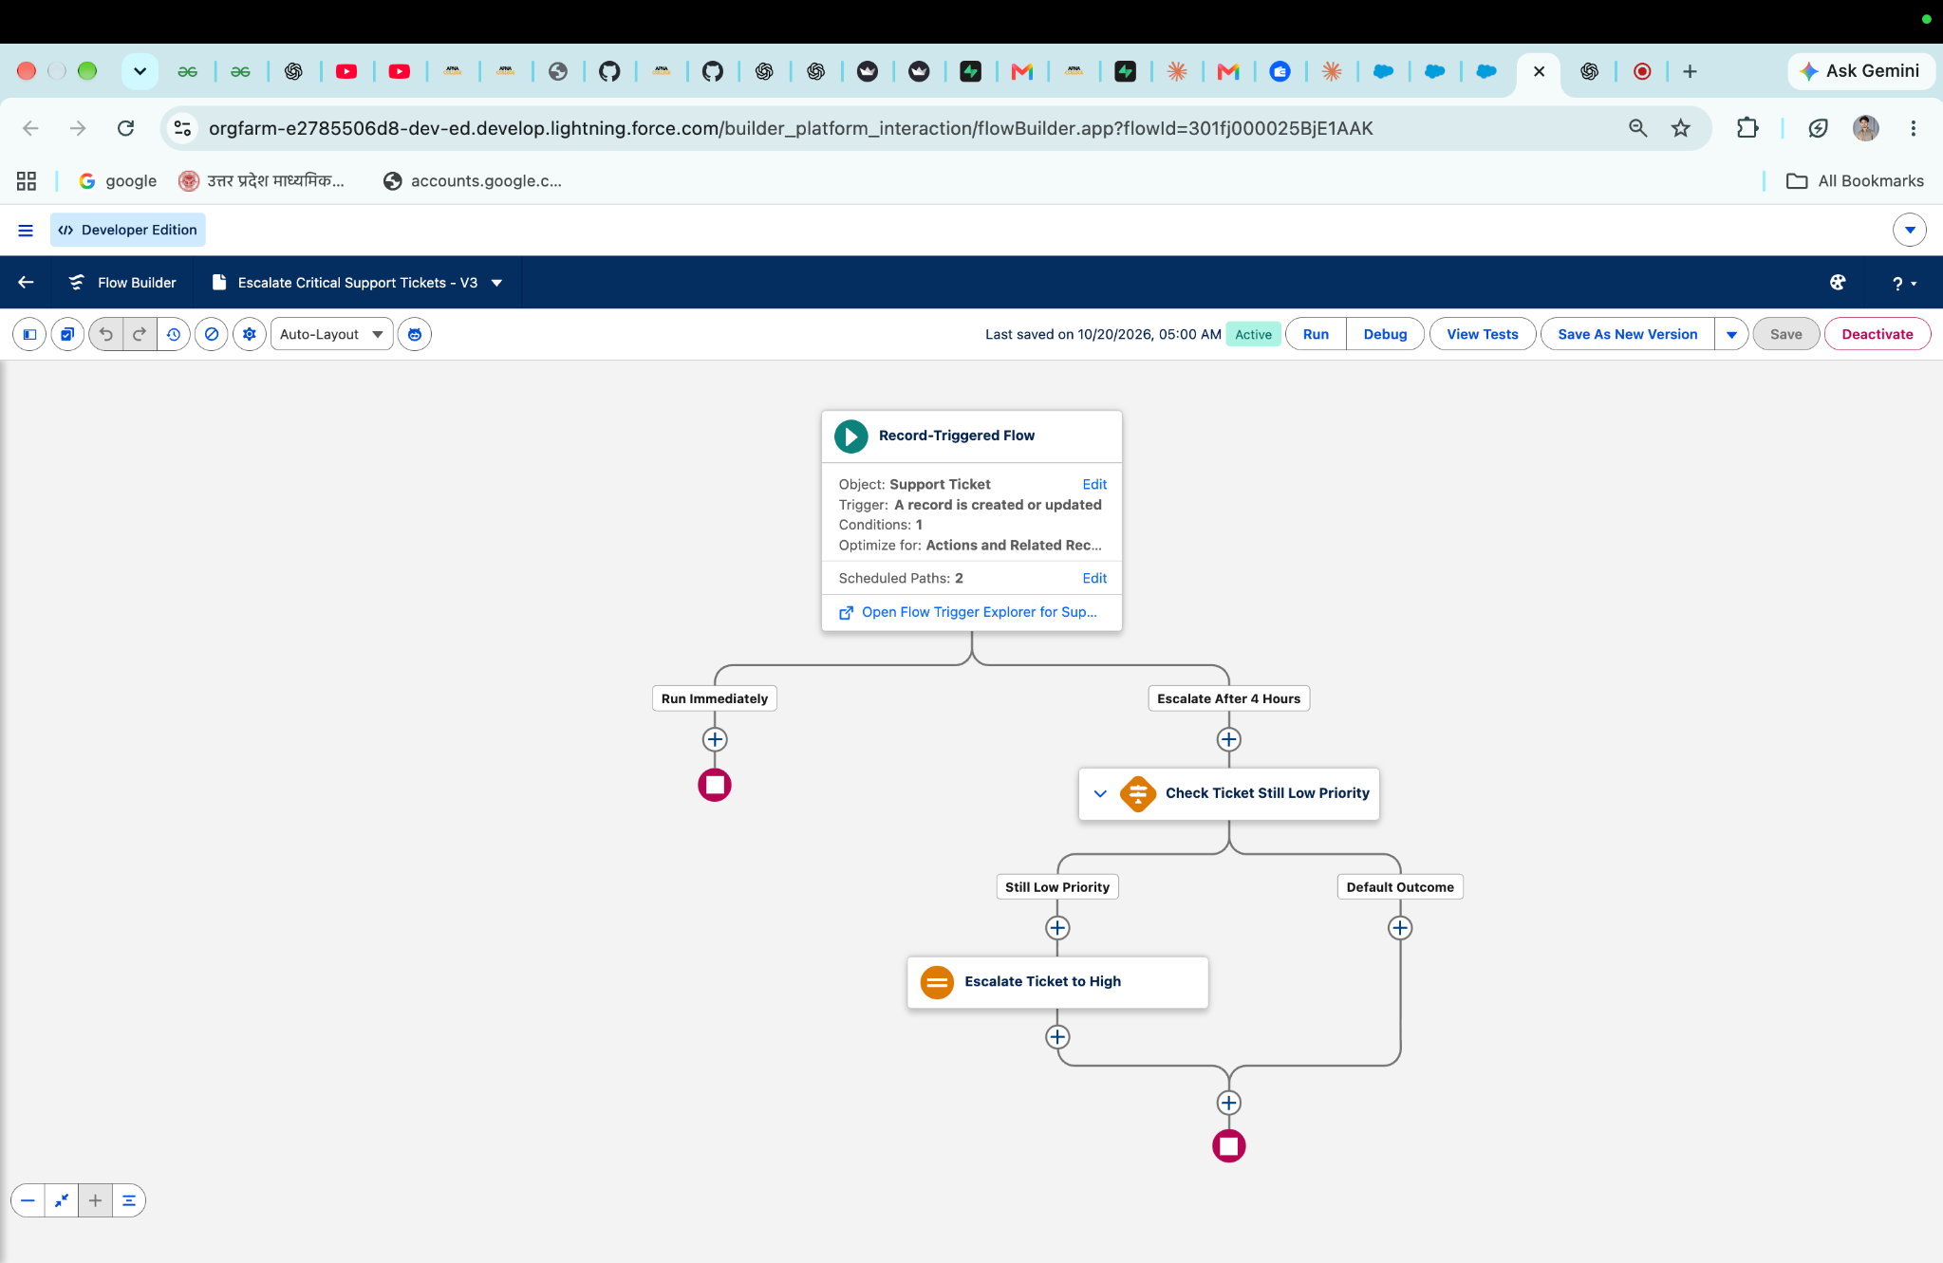
Figure 2. Set Support Ticket SLA flow and priority branches.
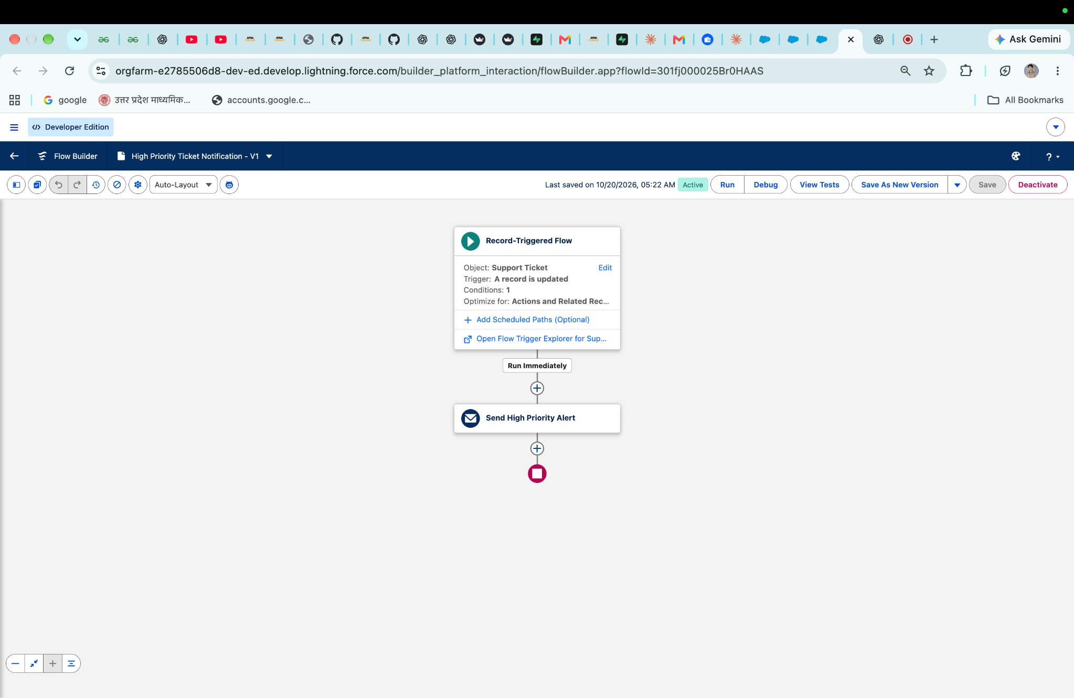
Figure 3. SLA Breach Detection flow and breach alert.
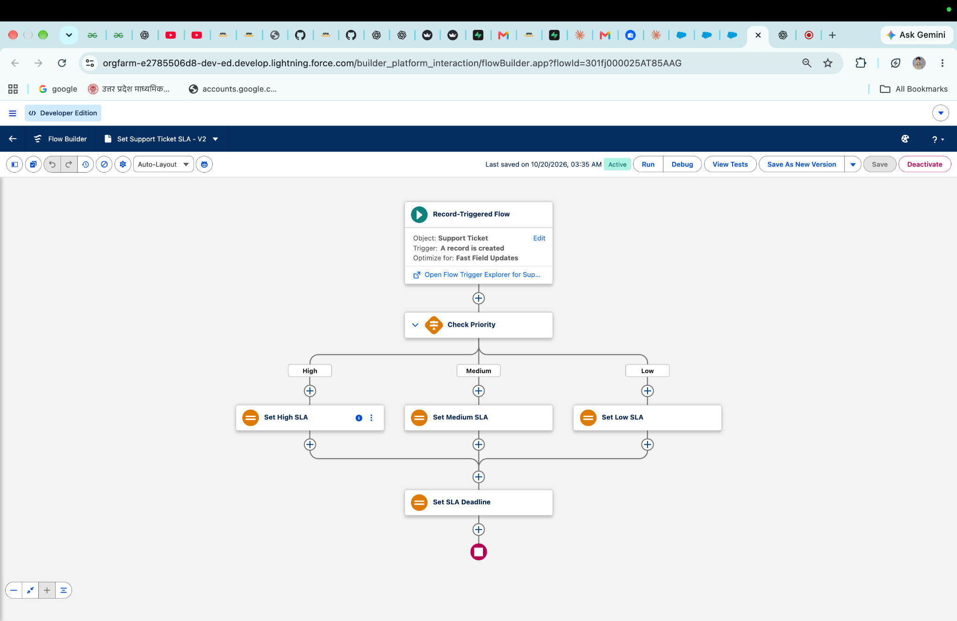
Figure 4. SLA Deadline Reminder flow.
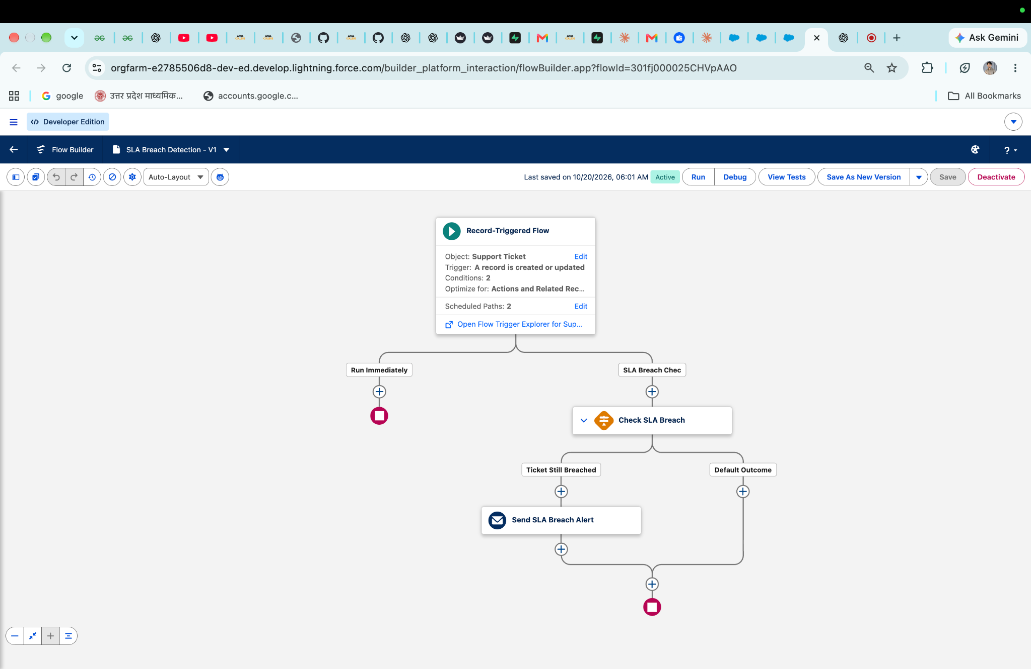
Figure 5. Telecom Support Dashboard donut chart.
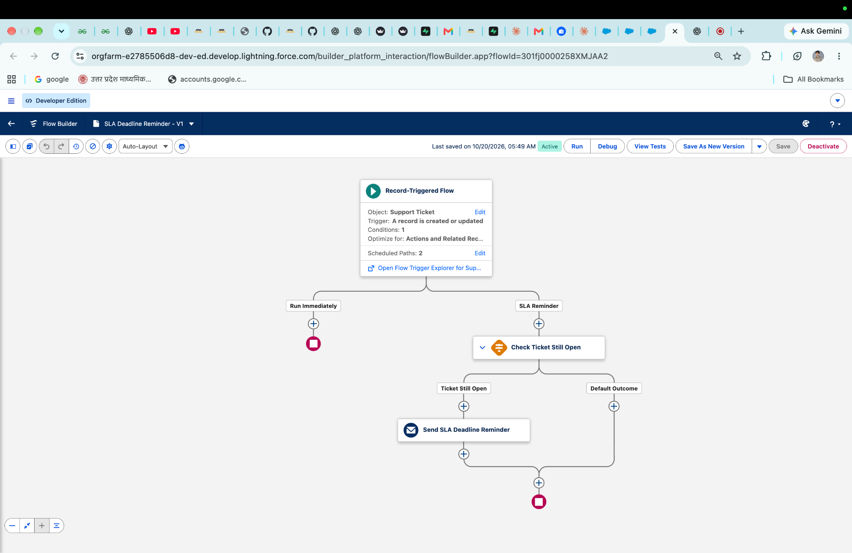
Figure 6. Escalate Critical Support Tickets four-hour path.
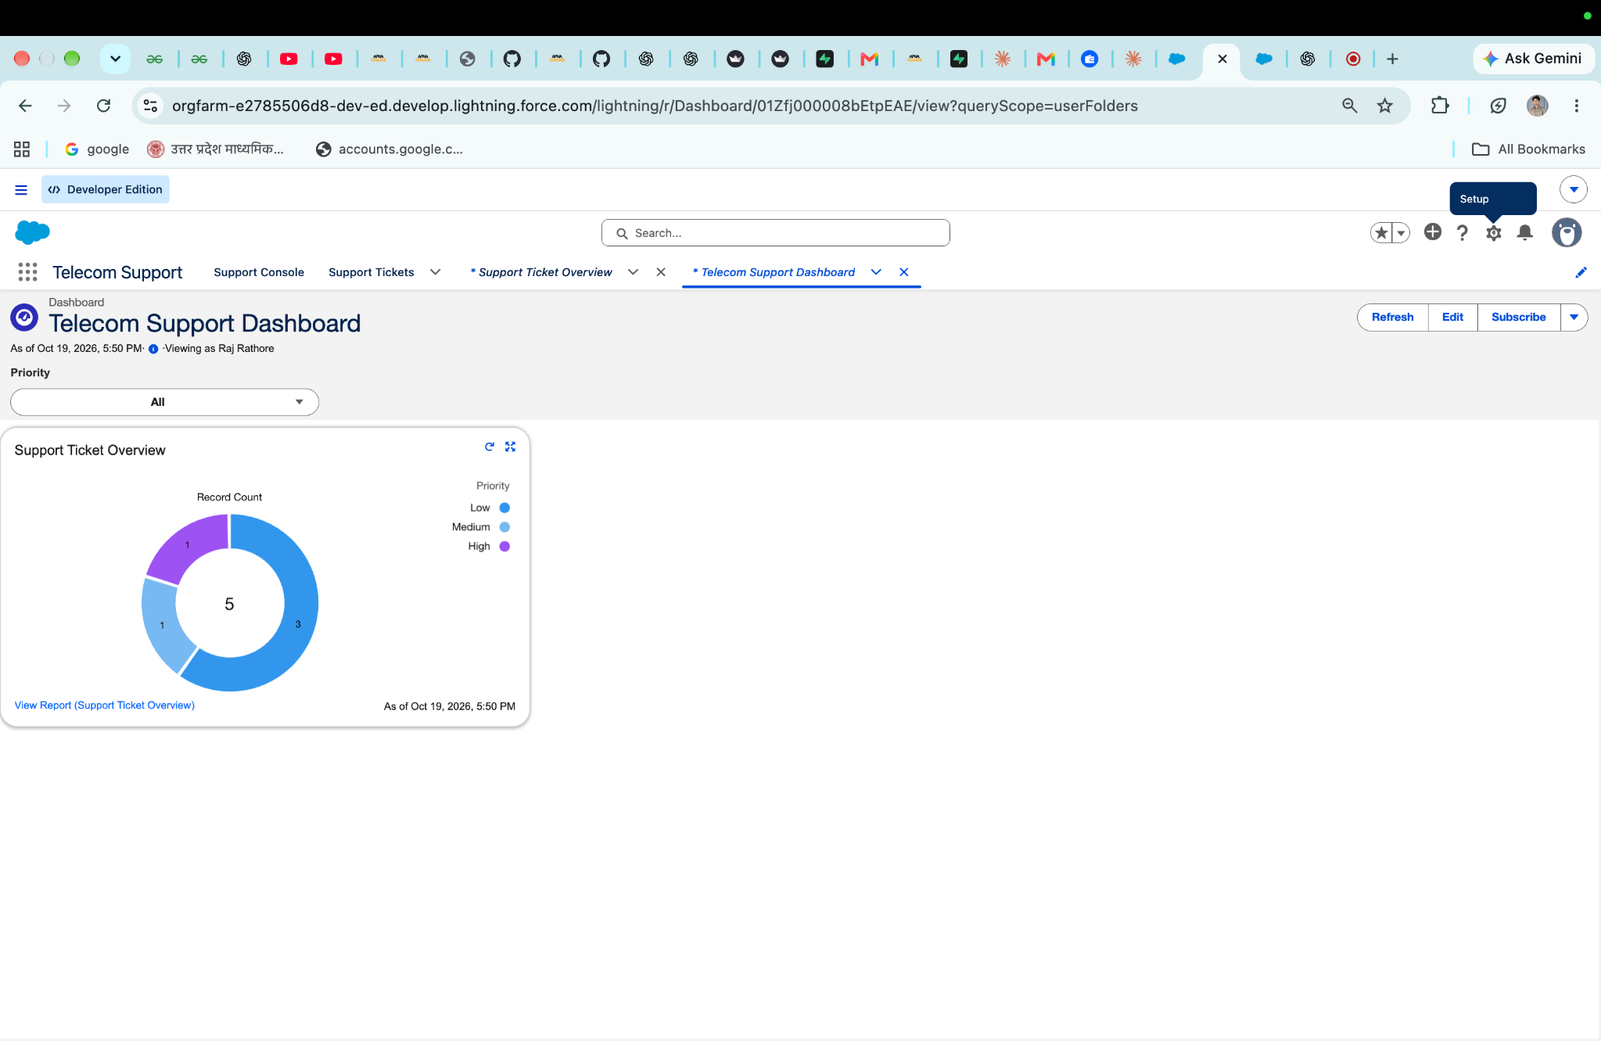
Figure 7. High Priority Ticket Notification flow.
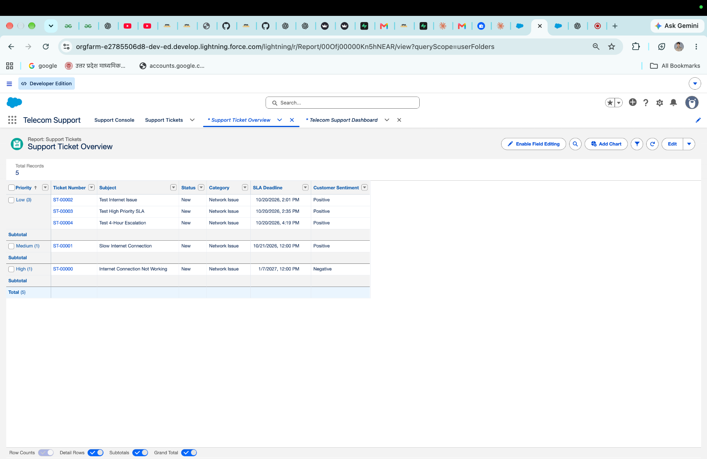

10. Conclusion
The implementation demonstrates a declarative Salesforce support workflow combining ticket data, priority-based SLA calculation, scheduled escalation, email notifications, and reporting. It is suitable as an academic or demonstration project. Complete end-to-end testing of scheduled actions and email delivery before describing it as production-ready.

